**Creation of tables**

|  |  |
| --- | --- |
| Team id | LTVIP2025TMID29041 |
| Project Name | Calculating Family Expenses |
| College Name | Kandula Lakshumma Memorial College of Engineering for Women |
| course | Computer Science Engineering |

**3. Making Number Field An Auto-Number**

**3.1 Number field**

* Double click on the number field/column

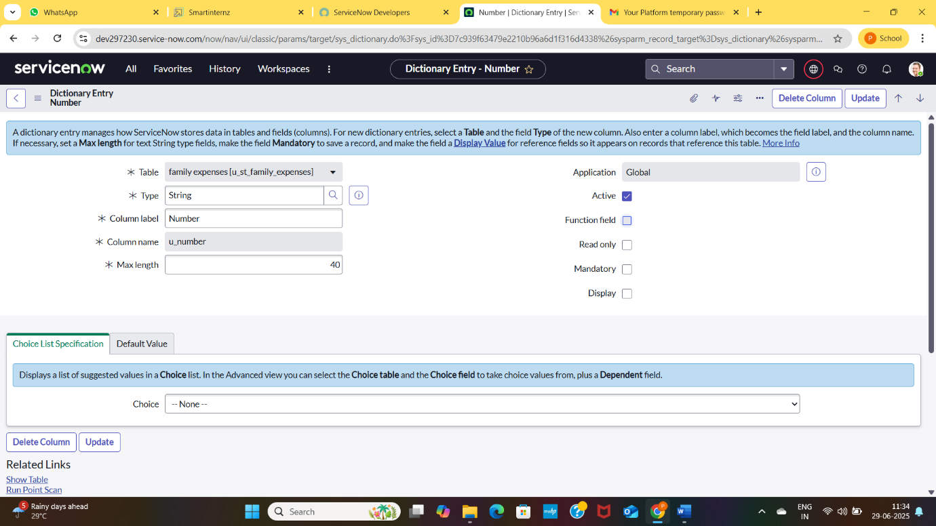

* Go down and doble click on Advance View
* In default value:
* Use dynamic default: check the box
* Dynamic default value :get next padded number
* Click on update

**3.2 Number maintenance**

* Go to All >> In the filter search for Number Maintenance >> select Number Maintenance
* Click on New.
* Enter the below Details:
* Table : Family Expenses
* Prefix : MFE

* Click on Submit